# **Metro Path Routing Software**

# Enhanced model software for route planner of the Metro System to find minimum travel time with respect to given source and destination in given map.



Design

* Structure based graph connected to windows forms interface.

Assumptions

* A train will depart even for a single person
* Availability of train to given start station and destination is independent of time.
* Length of train is zero or at most one train travel at once in whole paths.



Implementation details.

Node

(Station)

Edge

(Path between two stations)



# Map implement as a graph. Nodes and Edges are same as Stations and paths



## Cost of edge is defined as a time range between two stations

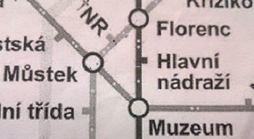

## Path with shortest time decide using Dijkstra algorithm after creating graph



Test methodology and analysis of test results

**Eg: 1**

|  |  |  |  |
| --- | --- | --- | --- |
| Station | Line | Time to next | Total time |
| Hradcanka  Malostranska  Staromestska  Mustec  Muzeum | A  A  A  A  A | 2mins  2mins  2mins  1min  - | -  2mins  4mins  6mins  7mins |

|  |  |  |  |
| --- | --- | --- | --- |
| Distance to next(x0. km) | Time to next(min) | Line | Station |
| 2  2  2  1  0 | 2  2  2  1  0 | A  A  A  A  A | Hradcanka  Malostranska  Staromestska  Mustec  Muzeum |

Expected result Application result

**Eg: 2**

|  |  |  |  |
| --- | --- | --- | --- |
| Station | Line | Time to next | Total time |
| Staromestska  Mustec  NR  Florenc | A  A  B  B | 2mins  1mins  2mins  - | -  2mins  4mins  6mins |

Expected result Application result

|  |  |  |  |
| --- | --- | --- | --- |
| Distance to next(x0. km) | Time to next(min) | Line | Station |
| 2  2  1  1 | 2  4  2  1 | A  A  B  B | Staromestska  Mustec  NR  Florenc |

Time Optimized Path

|  |  |  |  |
| --- | --- | --- | --- |
| Distance to next(x0. km) | Time to next(min) | Line | Station |
| 2  1  1  1  0 | 2  1  1  2  0 | A  A  A  C  B | Staromestska  Mustec  Museum  Hlavni nadrazi Florenc |



How the program works?

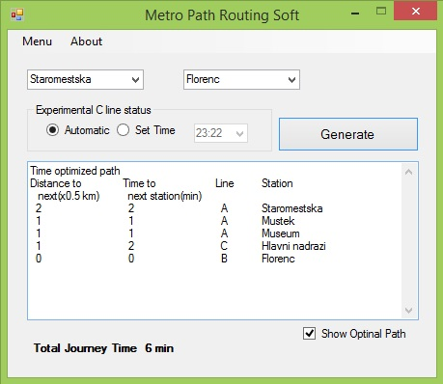

Show optional path (if available)

Set Time Manually

Load Time from System

Choose End Station

Choose Start Station

* Step 1 – Select start station by 1st popup.
* Step 2 – Select start station by 2nd popup.
* Step 3 – simply click Generate button.

(Automatic – program work by system time

Set time – manually set time)

Note : Msvcr120d.dll is required for running the application.

Team members.



* M.P.K.G De Silva (2013cs022)
* M.G.M Madhushanka(2013cs067)
* P.D.J.S Jayaratna(2013cs048)